
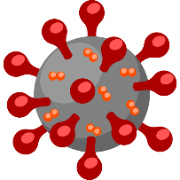




Practice Materials
Links 2-3 resources student can use to practice what they learned

Exit Ticket
How will you assess learnings?

Interactions in ZOOM
Link the chat, use/no, and poll questions

Tools used to Deliver this Lesson
Besides Zoom, what other materials are you using?

Key Resources
Link to sites, documents and other materials used in this lesson

Class | Date
Lesson Plan Information
Objectives
List the learning targets covered during this lesson

Online Class Duration
Start Time: 00am
End Time: 00pm
Video Conferencing for Online Class

Write school name here
Write Address here
Write phone no here
Write email address here
Lesson Plan
(For Covid 19 Situation)

