

Employee Complaint Form
Our company takes all employee complaints—including those of discrimination, harassment, unethical conduct or safety violations, as serious matters. So that we may properly investigate your concern, you are requested to fill out this form completely and return it as soon as possible. Please use additional sheets of paper where needed. After a prompt and thorough investigation into your complaint, you will be notified of the company’s intended action. Should you have any questions about the process, please set them forth at the end of this form and we’ll do our best to answer them. Thank you!
Employee Name |  | Date
Department |  | Supervisor Name
Please describe in as much detail as possible the nature of your complaint
Please attach or identify all known persons, documents and witnesses to your concerns.
Are there any other employees you know of with a similar complaint?
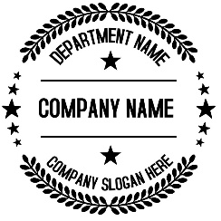
Please describe how the actions you complain about have affected your ability to perform your job.
Please describe any solutions you believe can help resolve your complaint.
Please provide any additional matter or comments you wish the company to consider when investigating your complaint (please use additional paper if needed).
I declare that the facts set forth in this complaint form are true and accurate pursuant to the penalty of perjury under the laws of this State.
Employee Signature |  | Date

