
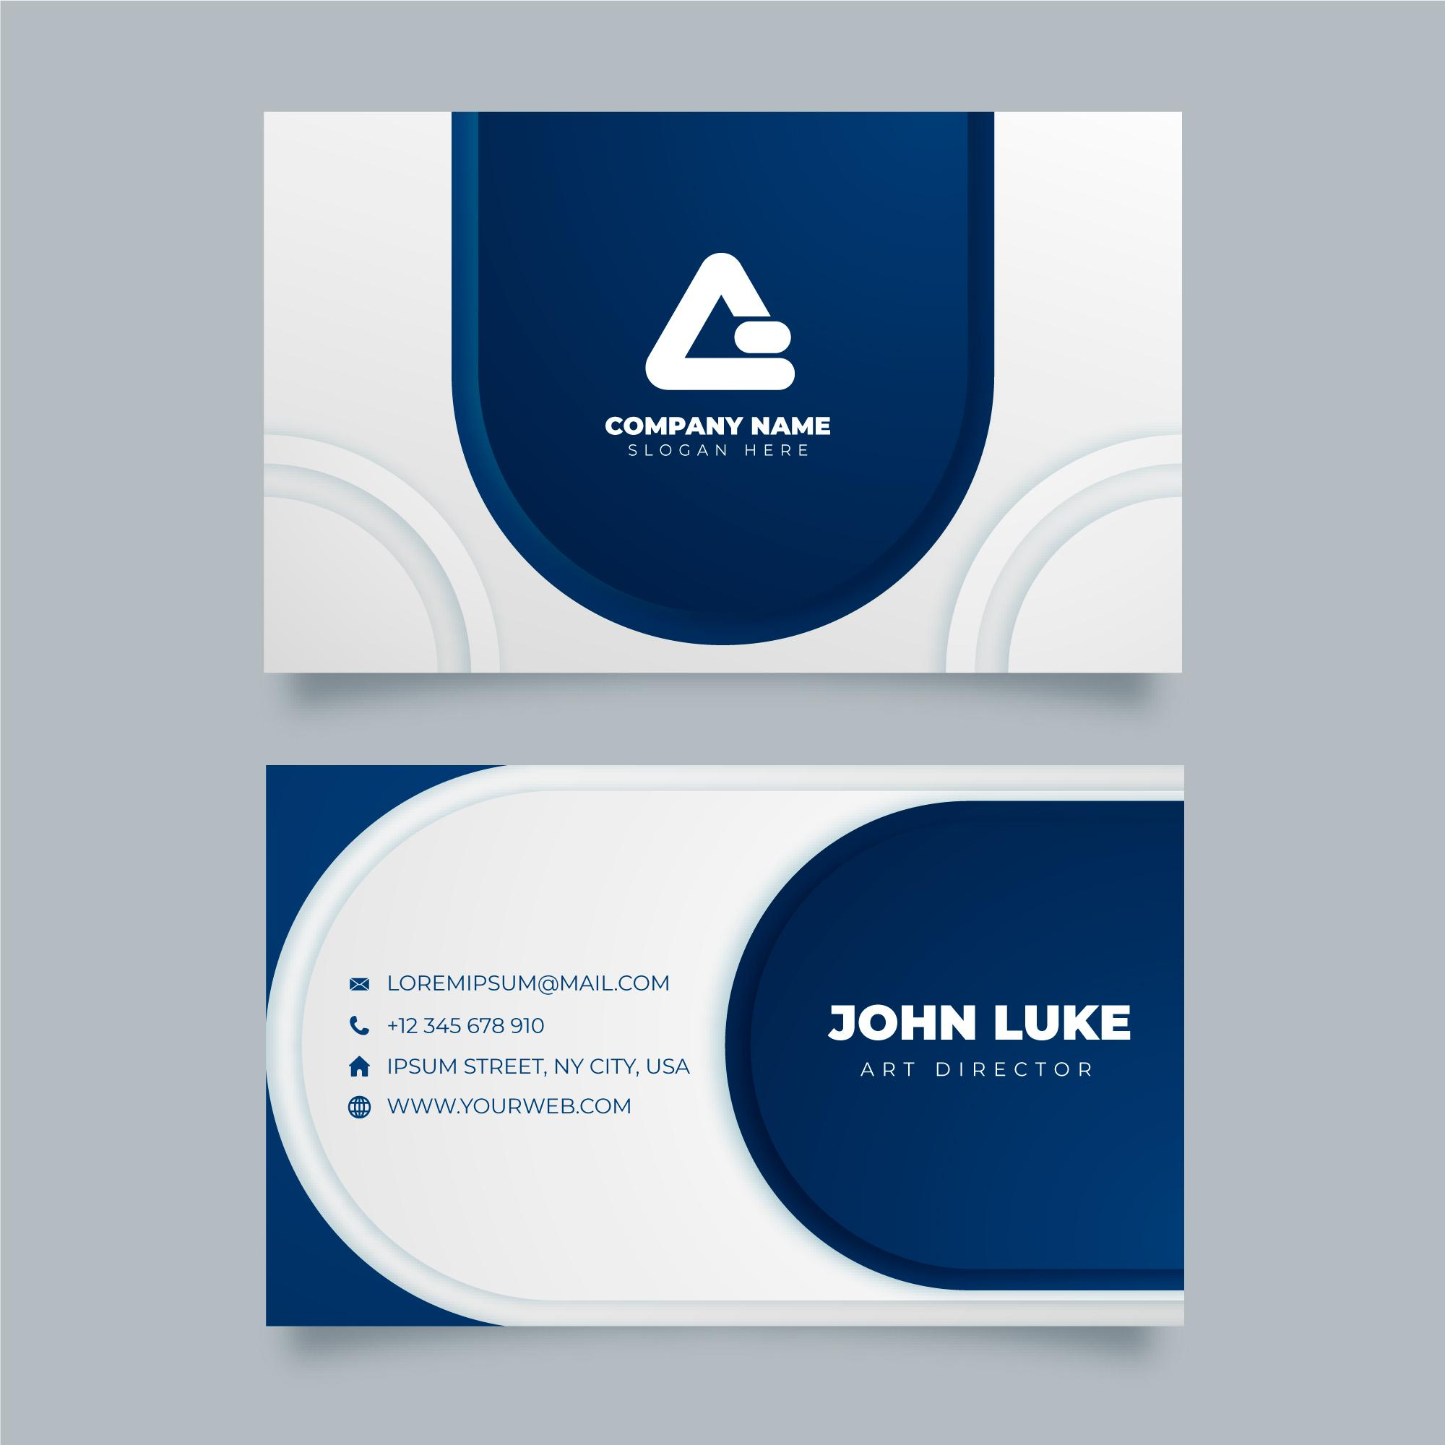
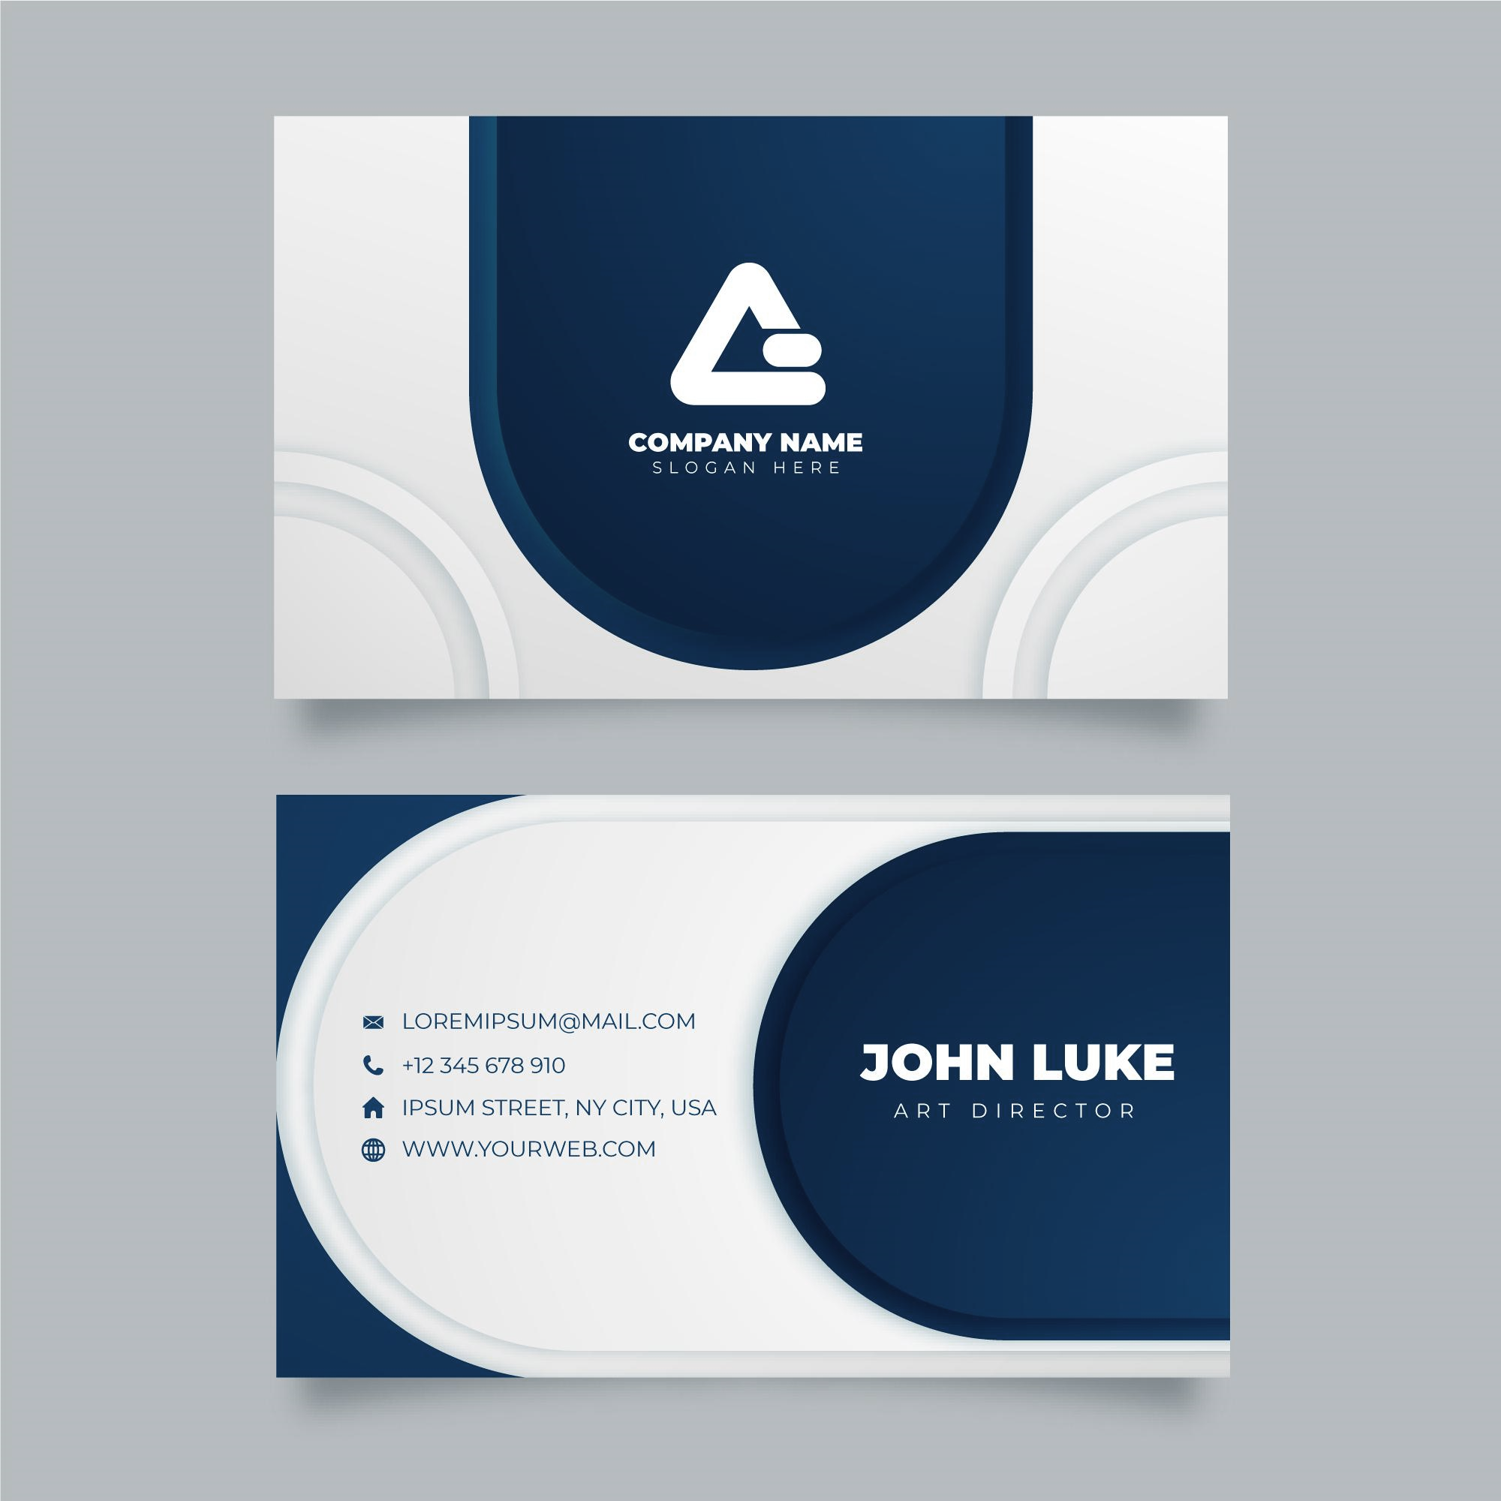
Happy Photography
PHOTOGRAPHY
GIFT CERTIFICATE
Lorem ipsum dolor sit amet, Consectetur adipiscing elit. Vivamus vitea luctus leo, vitae. Dignissim quam.Sed placerat, neque in ele. entum euismod, risus.Sed urna Purus, volute. Pat quis varius id, fragile non-urna.

Given to: Indigo Wynn
From: Oliver Dalton
Get
$500.00
Off your next session!

Valid until December 2022
Terms & Conditions
Lorem ipsum dolor sit amet, Consectetur adipiscing elit. Vivamus vitea luctus leo, vitae. Dignissim quam.Sed placerat, neque in ele. entum euismod, risus.Sed urna Purus, volute. Pat quis varius id, fragile non-urna.
Lorem ipsum dolor sit amet, Consectetur adipiscing elit. Vivamus vitea luctus leo, vitae. Dignissim quam.Sed placerat, neque in ele. entum euismod, risus.Sed urna Purus, volute. Pat quis varius id, fragile non-urna.

Happy Photography
PHOTOGRAPHY
GIFT CERTIFICATE
Lorem ipsum dolor sit amet, Consectetur adipiscing elit. Vivamus vitea luctus leo, vitae. Dignissim quam.Sed placerat, neque in ele. entum euismod, risus.Sed urna Purus, volute. Pat quis varius id, fragile non-urna.

Given to: Indigo Wynn
From: Oliver Dalton
Get
$500.00
Off your next session!

Valid until December 2022
Terms & Conditions
Lorem ipsum dolor sit amet, Consectetur adipiscing elit. Vivamus vitea luctus leo, vitae. Dignissim quam.Sed placerat, neque in ele. entum euismod, risus.Sed urna Purus, volute. Pat quis varius id, fragile non-urna.
Lorem ipsum dolor sit amet, Consectetur adipiscing elit. Vivamus vitea luctus leo, vitae. Dignissim quam.Sed placerat, neque in ele. entum euismod, risus.Sed urna Purus, volute. Pat quis varius id, fragile non-urna.

Happy Photography
PHOTOGRAPHY
GIFT CERTIFICATE
Lorem ipsum dolor sit amet, Consectetur adipiscing elit. Vivamus vitea luctus leo, vitae. Dignissim quam.Sed placerat, neque in ele. entum euismod, risus.Sed urna Purus, volute. Pat quis varius id, fragile non-urna.

Given to: Indigo Wynn
From: Oliver Dalton
Get
$500.00
Off your next session!

Valid until December 2022
Terms & Conditions
Lorem ipsum dolor sit amet, Consectetur adipiscing elit. Vivamus vitea luctus leo, vitae. Dignissim quam.Sed placerat, neque in ele. entum euismod, risus.Sed urna Purus, volute. Pat quis varius id, fragile non-urna.
Lorem ipsum dolor sit amet, Consectetur adipiscing elit. Vivamus vitea luctus leo, vitae. Dignissim quam.Sed placerat, neque in ele. entum euismod, risus.Sed urna Purus, volute. Pat quis varius id, fragile non-urna.

